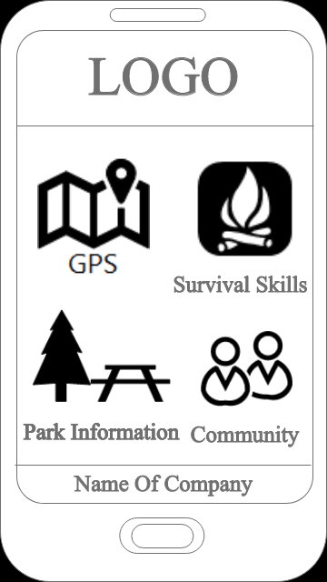**Page Description:**

This is the main page of our app.

It provides the user access to the GPS, Community,

Park Information and Survival Skills.

**User Action:**

User have to enter to the app.

**Business Rules:**  
Display a default logo at the top and the name of company at the

bottom.

User have ability to view all icons-buttons on the screen.

User can access only one icons-buttons at time.

To exit app user, have to click the button on the phone.

**Potential Enhancements/Changes/Issues:**

Provide to the user ability to login into device.

**Main Page Summary:** The presented page shows the main page

of app that includes four icons-buttons that will provides different pages with interaction to the user.

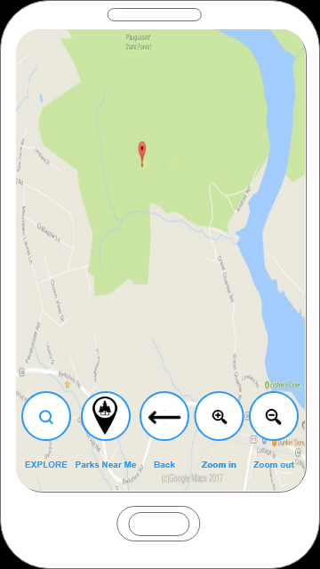**Page Description:**

This is the GPS. Here user can see map, zoom in/out buttons, back button, search button and button with picture of location sign with a tree inside.

**User Action:**

User have to enter to the app and choose GPS.

**Business Rules:**

All buttons are locating by default at the bottom.

Only one bottom works at one time.

Search window is hidden as long as user didn’t click Explore button.

**Potential Enhancements/Changes/Issues:**

Provide an exit button.

**Main Page Summary:**

To find path in park user have to click at the Explore bottom.

To find parks that near user location, user have to click on the

Bottom Parks Near me.

To return user have to click at the error.

To return on the main page user have to click at the return button at the phone.

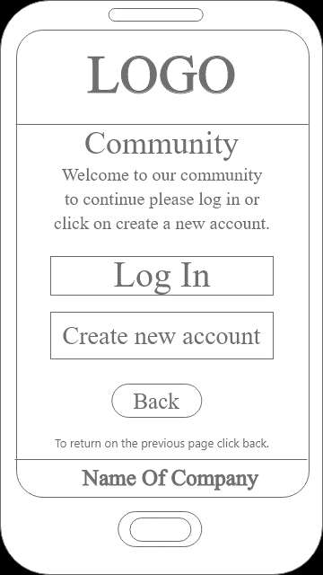**Description:**

This is the Community Main Page. Here user can Login into their personal account or create a new account.

**User Action:**

User have to enter to the app and choose Community.

**Business Rules:**

All buttons are locating by default at the bottom.

Only one bottom works at one time.

Search window is hidden as long as user didn’t

click Explore button.

**Potential Enhancements/Changes/Issues:**

Provide an exit button.

**Main Page Summary:**

User has the option of logging into their account or creating a new account or backing out back to the app main menu.

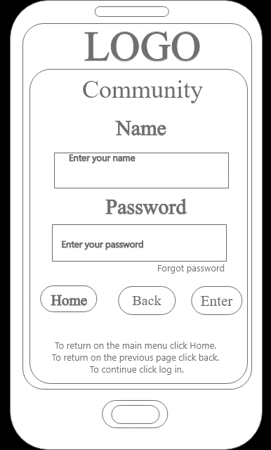

**Page Description:**

This is the Login page. Here user can login to their personal account or request a password change if they cannot remember their current password.

**User Action:**

User have to enter to the app and choose Community and then Login.

**Business Rules:**

All buttons are locating by default at the bottom.

Only one bottom works at one time.

**Potential Enhancements/Changes/Issues:**

Provide an exit button.

**Main Page Summary:**

To go back to the Community Main Page, press the Back button to proceed back to the Community Main Page.

To return to the main menu, press the Home button to cancel any actions on the page and return to the main menu.

After inputting username and password, press Enter and if the information is valid, then user is accepted and proceeds to the Community Homepage.

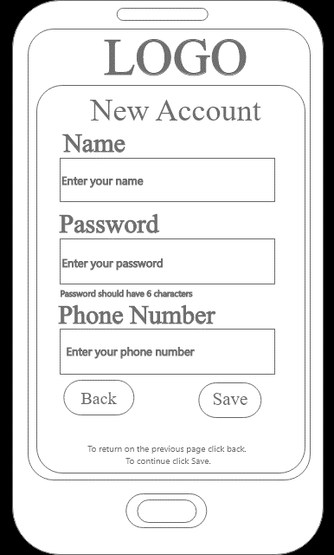

**Page Description:**

This is the New Account page. Here user can create a personal account to use the Community function

**User Action:**

User have to enter to the app and choose Community and then Create New Account.

**Business Rules:**

All buttons are locating by default at the bottom.

Only one bottom works at one time.

**Potential Enhancements/Changes/Issues:**

Have a Check feature to make sure the phone number used isn’t already in the database.

Provide an exit button to the main menu.

**Main Page Summary:**

To go back to the Community Main Page, press the Back button to proceed back to the Community Main Page.

To return to the main menu, press the Home button to cancel any actions on the page and return to the main menu.

After inputting username and password, press Enter and if the information is valid, then user is accepted and proceeds to the splash screen to return to the login page.

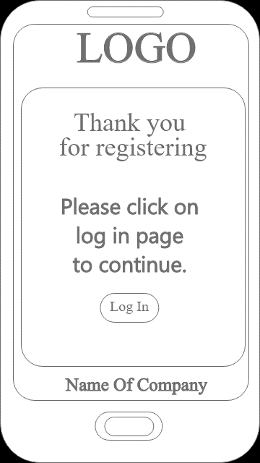

**Page Description:**

This is the Create New Account splash page. Here user is verified and is now able to login into the community by pressing the login button to move to the login page

**User Action:**

User have to enter to the app and choose Community and then Create New Account and successfully create an account and save it.

**Business Rules:**

All buttons are locating by default at the bottom.

Only one bottom works at one time.

**Potential Enhancements/Changes/Issues:**

Provide an exit button in case the user does not wish to continue to the login screen immediately.

**Main Page Summary:**

After inputting username and password and press Enter and if the information is valid, then user is moved to the splash screen and proceeds to the Login page.

**Page Description:**

This is the Community page. Here user can enter a group chat with other people they have linked up with and can upload/take pictures and post them on their pictures page.

**User Action:**

User have to enter to the app and choose Community and then Login successfully to reach the Community Main Menu.

**Business Rules:**

All buttons are split between left and right with the menu buttons above.

Only one bottom works at one time.

**Potential Enhancements/Changes/Issues:**

Move the exit button towards the bottom to keep with app default button layout.

**Main Page Summary:**

To go to the Community Main Menu, login into your personal account and confirm your login.

After inputting username and password, press Enter and if the information is valid, then user is accepted and proceeds to the Community Main Menu.

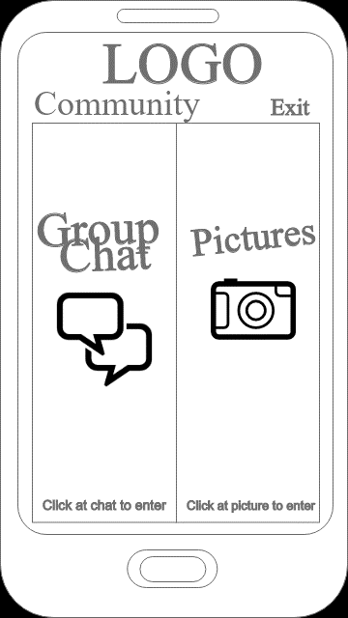

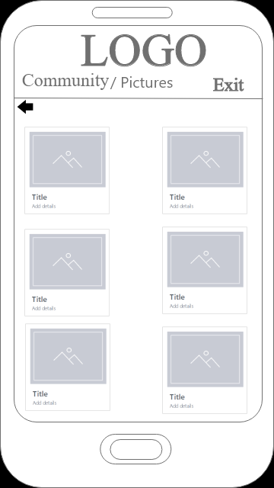

**Page Description:**

This is the Pictures page. Here user can view/upload/take/delete/share photos at their leisure to their personal accounts

**User Action:**

User have to enter to the app and choose Community and then Login and after successfully logging in, go to the pictures.

**Business Rules:**

All pictures are sorted in a 2-column feature.

Select a picture and it zooms in and allows user to share/etc. the pictures selected.

Only one button works at one time.

**Potential Enhancements/Changes/Issues:**

Move the exit button towards the bottom to keep with app default button layout.

**Main Page Summary:**

Pictures are displayed to the user.

User can manipulate the pictures to whatever they want to do.

When user is finished in this section, press the exit button to return to the Community Main Menu.

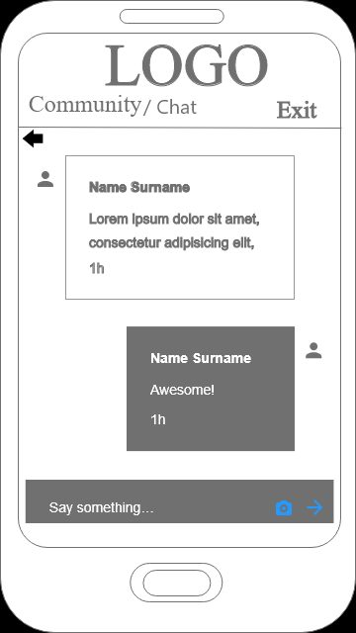

**Page Description:**

This is the Group chat page. Here user can chat with other users. If user has multiple chats running, the back button near the top left returns user to the chat groups.

**User Action:**

User have to enter to the app and choose Community and then Login and after successfully logging in, go to the group chat button.

**Business Rules:**

Chats will be sorted by most recent group on top.

Chats can be removed in case user quits group or mutes certain chats.

**Potential Enhancements/Changes/Issues:**

Move the exit button towards the bottom to keep with app default button layout.

**Main Page Summary:**

Group chats are displayed to the user.

User can chat with groups whenever they want

When user is finished in one group chat, use the back button to return to the group chats menu.

When user is finished in this section, press the exit button to return to the Community Main Menu.

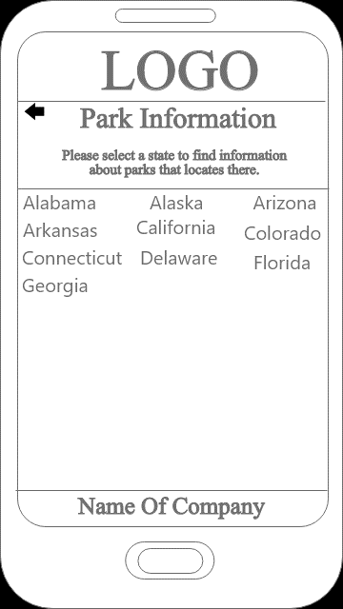

**Page Description:**

This is the Parks Information Main Menu page. Here user can select which state to view their respective parks. When user is finished in this part of the menu, the back button will return user to the App Main Menu.

**User Action:**

User have to enter to the app and choose Park Information button.

**Business Rules:**

All states are sorted in a 3-column feature.

Select a state and it opens to feature the parks in that state

Only one state button works at one time.

**Potential Enhancements/Changes/Issues:**

Move the exit button towards the bottom to keep with app default button layout.

Have the user type in the state name as another option.

**Main Page Summary:**

States are displayed to the user to select

The selected state will then list their parks for the user

When user is finished in this section, press the exit button to return to the App Main Menu.

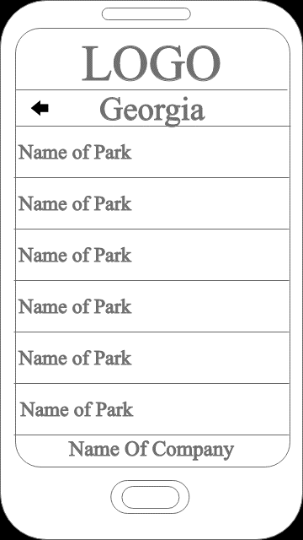

**Page Description:**

This is the state parks page. Here user can select the various parks in that state to view their information

**User Action:**

User have to enter to the app and choose Park Information and then select a state to view.

**Business Rules:**

All parks are sorted in a scroll list.

Select a park and it zooms in and allows user to see a picture and display information on that park.

Only one button works at one time.

Use the back button to return to the park list.

**Potential Enhancements/Changes/Issues:**

Move the exit button towards the bottom to keep with app default button layout.

**Main Page Summary:**

Lists the parks within that selected state.

After selecting a park, it allows user to view information on that park.

When user is finished in the park info screen, use the back button to return to the state park page.

When user is finished in that state page, use the back button to return to the Parks Information Main Menu.

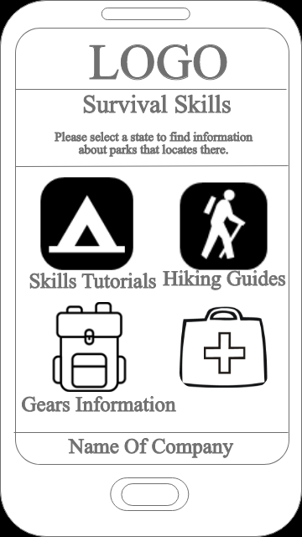

**Page Description:**

This is the Survival Skills page. Here user has access to various tools to aid in their travels like guides, tutorials, and gear information.

**User Action:**

User have to enter to the app and choose the Survival Skills button

**Business Rules:**

All options are sorted in a 4-block system.

Select an option and it zooms in and allows user to enter that page.

Only one button works at one time.

**Potential Enhancements/Changes/Issues:**

Move the exit button towards the bottom to keep with app default button layout.

**Main Page Summary:**

Lists 4 options that user can select to get in-depth information on various topics for the user.

Each topic is unique in what they contain.

When finished, user can press the back button to return to the App Main Menu.

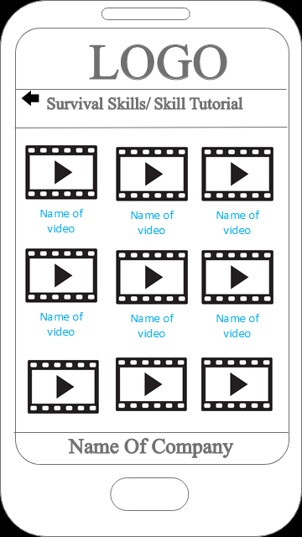

**Page Description:**

This is the Survival Skills - Tutorials page. Here user has access to various videos to aid in their travels like cooking, setting up camp, etc.

**User Action:**

User have to enter to the app and choose the Survival Skills button then press Skill Tutorials

**Business Rules:**

All videos are sorted in a list system.

Select an option and takes the user to YouTube so that they can view the video.

Only one button works at one time.

**Potential Enhancements/Changes/Issues:**

Move the exit button towards the bottom to keep with app default button layout.

Have the videos play in our video player instead of moving to a different app.

**Main Page Summary:**

Lists videos that user can select to get in-depth information on various tutorials for the user.

Each tutorial is unique in what they contain.

When finished, user can press the back button to return to the Survival Skills menu.

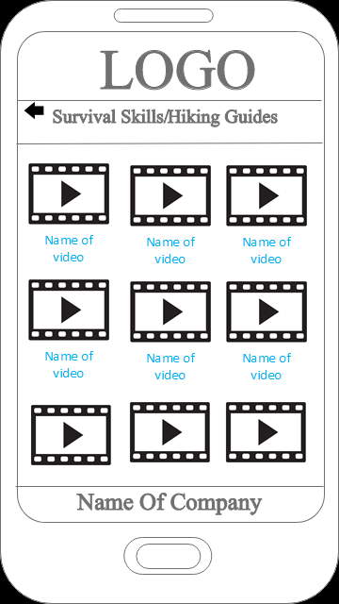

**Page Description:**

This is the Survival Skills – Hiking Guides page. Here user has access to various videos to aid in their travels like hiking tips, taking breaks, etc.

**User Action:**

User have to enter to the app and choose the Survival Skills button then press Hiking Guides

**Business Rules:**

All videos are sorted in a list system.

Select an option and takes the user to YouTube so that they can view the video.

Only one button works at one time.

**Potential Enhancements/Changes/Issues:**

Move the exit button towards the bottom to keep with app default button layout.

Have the videos play in our video player instead of moving to a different app.

**Main Page Summary:**

Lists videos that user can select to get in-depth information on various guides for the user.

Each guide is unique in what they contain.

When finished, user can press the back button to return to the Survival Skills menu.

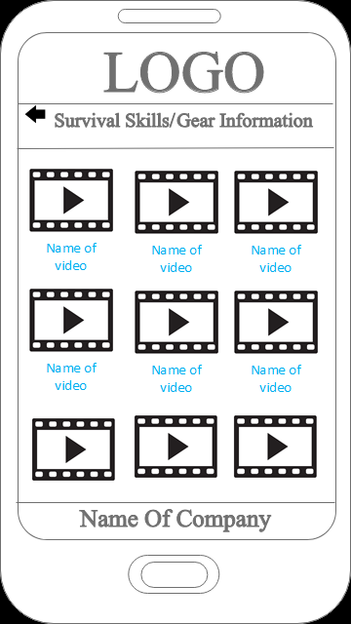

**Page Description:**

This is the Survival Skills – Gear Information page. Here user has access to various videos to go in-depth about various gears that they would need in order to travel correctly like camping bags, tents, materials for bags, etc.

**User Action:**

User have to enter to the app and choose the Survival Skills button then press Gear Information

**Business Rules:**

All videos are sorted in a list system.

Select an option and takes the user to YouTube so that they can view the video.

Only one button works at one time.

**Potential Enhancements/Changes/Issues:**

Move the exit button towards the bottom to keep with app default button layout.

Have the videos play in our video player instead of moving to a different app.

**Main Page Summary:**

Lists videos that user can select to get in-depth information on various gears for the user.

Each gear info video is unique in what they contain.

When finished, user can press the back button to return to the Survival Skills menu.

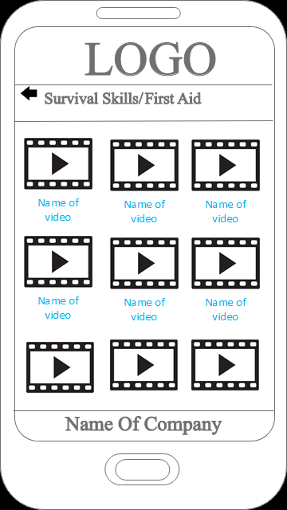

**Page Description:**

This is the Survival Skills – First Aid page. Here user has access to various videos to aid in their travels like patching up injuries, how to handle bear emergencies, etc.

**User Action:**

User have to enter to the app and choose the Survival Skills button then press First Aid

**Business Rules:**

All videos are sorted in a list system.

Select an option and takes the user to YouTube so that they can view the video.

Only one button works at one time.

**Potential Enhancements/Changes/Issues:**

Move the exit button towards the bottom to keep with app default button layout.

Have the videos play in our video player instead of moving to a different app.

**Main Page Summary:**

Lists videos that user can select to get in-depth information on various first aid guides for the user.

Each guide is unique in what they contain.

When finished, user can press the back button to return to the Survival Skills menu.